http://interviewquestionsbook.blogspot.in/2013/12/plsql-collections.html

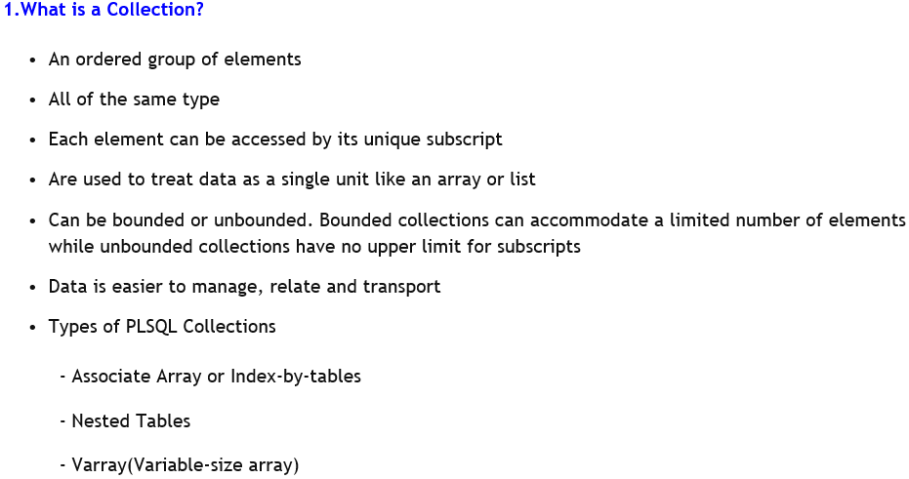

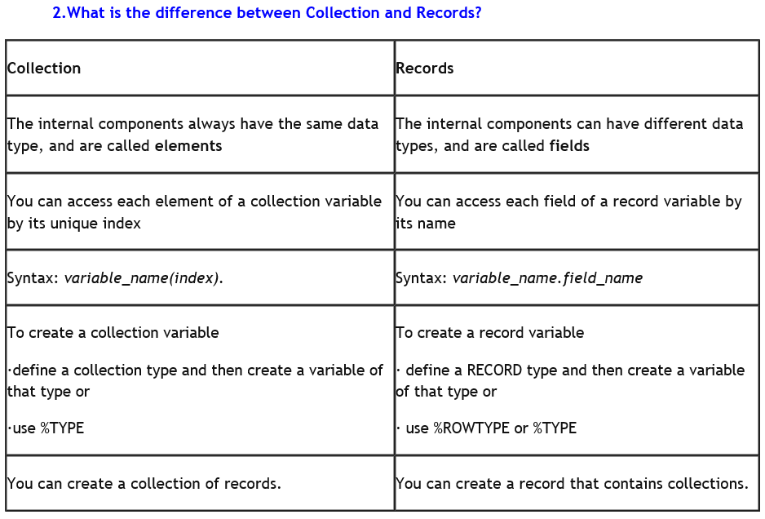

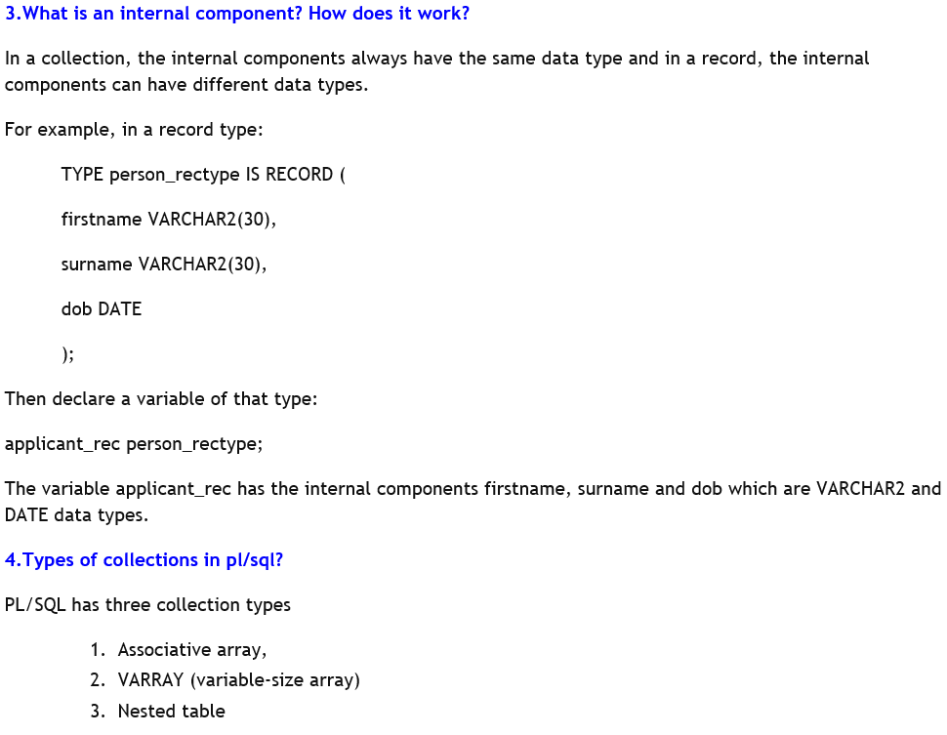

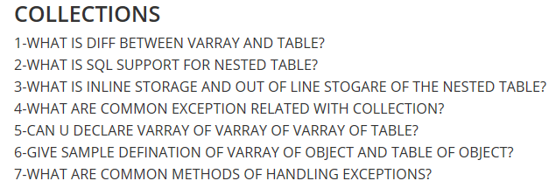http://www.geekinterview.com/Interview-Questions/Database/SQL

<http://interviewquestionsbook.blogspot.in/2013/12/plsql-new-features-in-oracle-11g.html>

<http://www.complexsql.com/hcl-interview-questions/>

https://www.slideshare.net/hirist/top-100-sql-interview-questions-and-answers